BLM  2-7  K.5.2.E.2a | Showing Emotion |  | 
Name |  | Grade | Date
Draw a line to match each picture with the correct word.

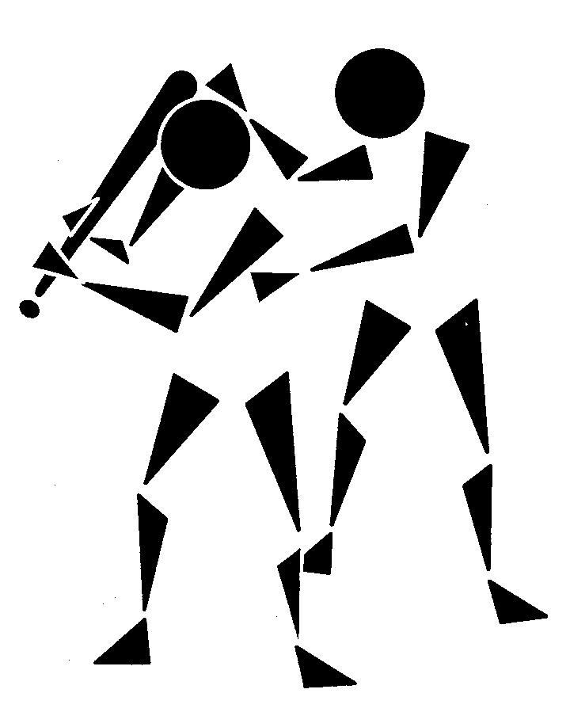
Cooperating

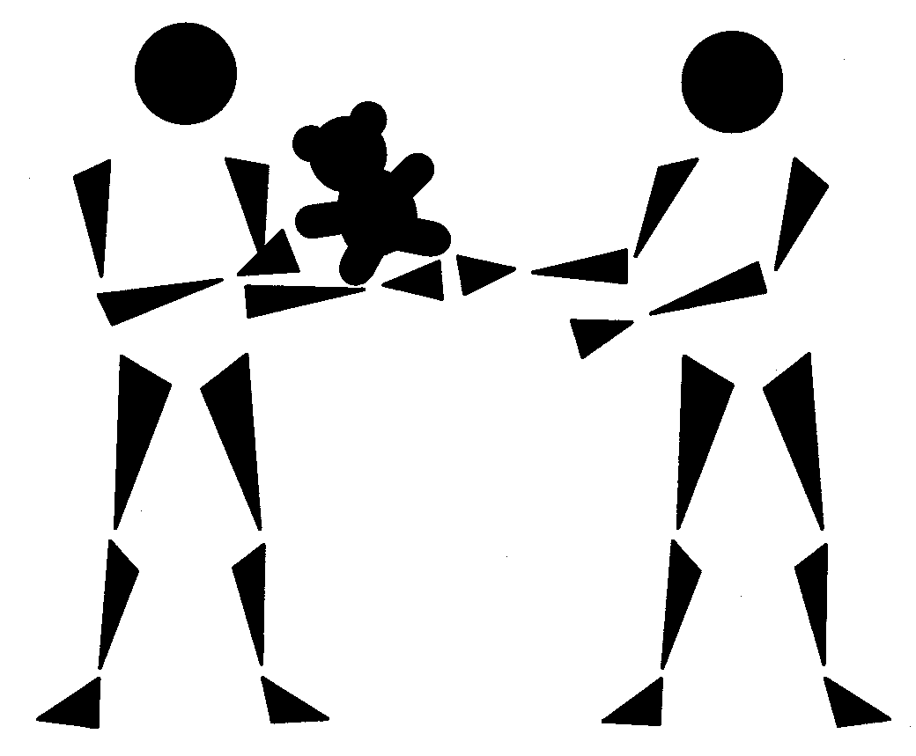

Helping

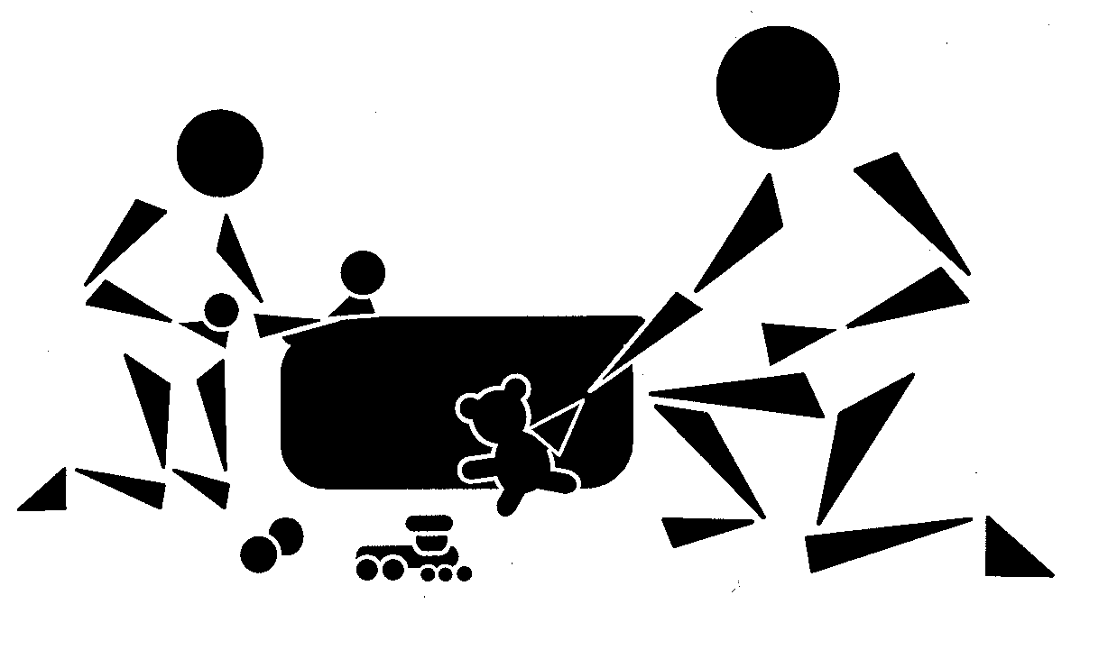
Caring



Sharing

