BLM  2-6  K.5.2.A.2 | How Do I Avoid Spreading Germs? |  |  |  | 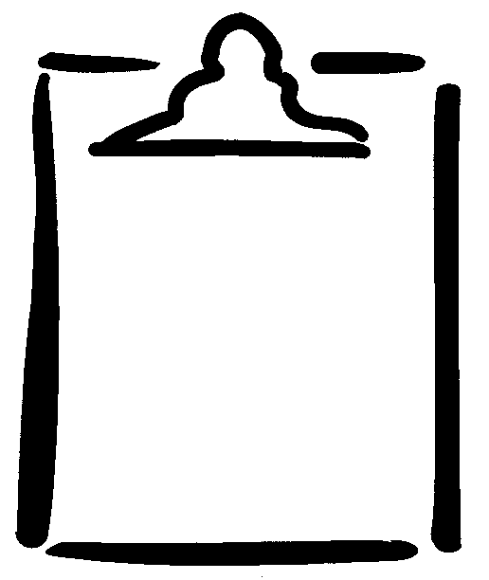
Name |  | Grade Class |  |  | Activity
What I Do |  |  | Always | Sometimes |  | Never
I wash my hands before
mealtime.

I avoid eating and
drinking from used or
dirty dishes, straws,
and cutlery.
I cover my mouth when I
sneeze or cough.
I wash my hands after I go
to the washroom.

I make sure that my

mouth does not touch the
water fountain.

What is another way that I can avoid spreading germs?

___________________________________________________________________________________________________

___________________________________________________________________________________________________

___________________________________________________________________________________________________

