BLM  2-2  K.3.2.B.1 | Be Smart about Safety  (continued) |  | 

Name Grade Date

Example |  | Safety Rule(s)

Tools

Internet Use

Stairs/Balconies

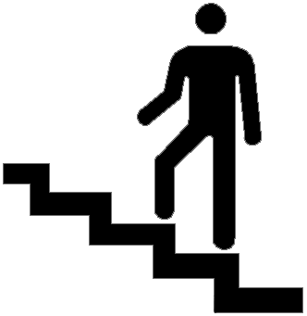

Weather

