BLM  2-2  K.3.2.B.1 | Be Smart about Safety |  | 

Name Grade Date

Example |  | Safety Rule(s)

Road Crossing

Bus Ridership

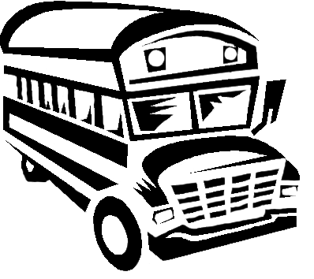

Tractors

Boats

Electricity
(continued)

