BLM  1-6  S.4.1.A.3 |  | I’m Responsible |  |  |  | 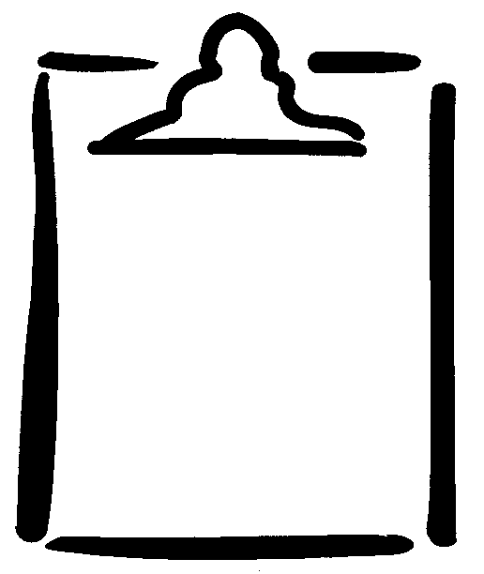
Name |  |  | Class |  | Date
Day | Activity  (e.g., rice table) |  |  | Responsible Behaviour  (e.g., played together) |  | How did I do?
Day |  |  |  |  |  | ☺ ☹
1

2

3

4

5

Teacher/Student Comments:

