MATERIALS: A set of property cards and a set of shape cards

PLAYERS: Groups of two to four

RULES: Shuffle the property cards and place them face down in a pile. Spread shapes face up in the centre of the table
Players take turns turning over the top property card. The player who turns over the property card then looks for all the shapes (cards) which have that property and places them next to the property card in front of him/herself.
Players may only take cards from the centre of the table but they should make note of the cards that have already been chosen by the other players.
Play ends when all of the property cards have been turned over.

SCORING: 2 points for each shape card chosen from the centre of the table.
1 point for each shape card already chosen by another player but identified as having the identified property
The winner is the player with the most points

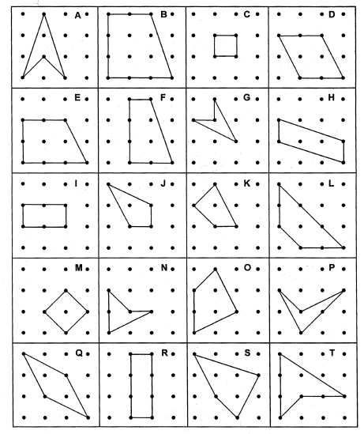
Area of 1 unit
One right angle
Two pairs of opposite angles equal
More than two right angles
One pair of opposite angles equal
Two equal sides
Two right angles
An obtuse angle
Rotational Symmetry
More than two equal sides
A reflex angle
Two pairs of parallel sides
Two equal angles
More than one axis of symmetry
No equal sides
One axis of symmetry
Area of 2 units
One pair of parallel sides
More than two equal angles
No equal angles

