Material: A number cube
One bingo card for each player
Counters

Players: Two to four

Rules: After each player chooses a bingo card, the first player rolls the number cube. Each player checks to see if the number rolled is on her own bingo card. If the number is in more than one square, each player decides which square should be covered. Only one square can be covered each turn. For example, if a five is rolled, any one of the following squares could be covered.

5
or or or ou . or

The second player rolls the number cube and the game continues until one of the players has covered four corners and a line (horizontal, diagonal or vertical).

Manitoba Education and Youth authorizes the complete or partial reproduction of this document for noncommercial educational use provided that the source is credited. Every effort has been made to provide proper acknowledgement of original sources and to comply with copyright law. If cases are identified where this has not been done, please notify Manitoba Education and Youth to correct any omissions.
Note to parents:

Dot Bingo is a game that requires subitizing. Subitizing is “instantly recognizing how many dots there are in a group”.
For example, a child who is subitizing can instantly state without counting how many dots are found in each of these figures.
This game and other dice games help students to subitize dot patterns.

Subitizing helps a child form mental pictures of numbers and to realize that a number can be represented in many ways.



Six is but it is also and

DOT BINGO

- Subitizing
- Addition


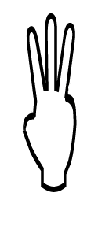
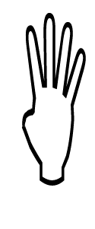
FREE
 | 1
 | 2
 | 6 |  |  | 4
 | 3 | 5

FREE | 1
2
 |  | FRE |  | 6
4 |  |  |  | 3
 |  |  | 5

3
FREE
 |  |  |  | 5
 | 6 |  | 2
1 |  |  |  | 4

FREE |  |  | 3
 | 2 |  | 6
 |  |  |  | 4
 | 1 |  | 5

