S–103

a | e | i | o | u

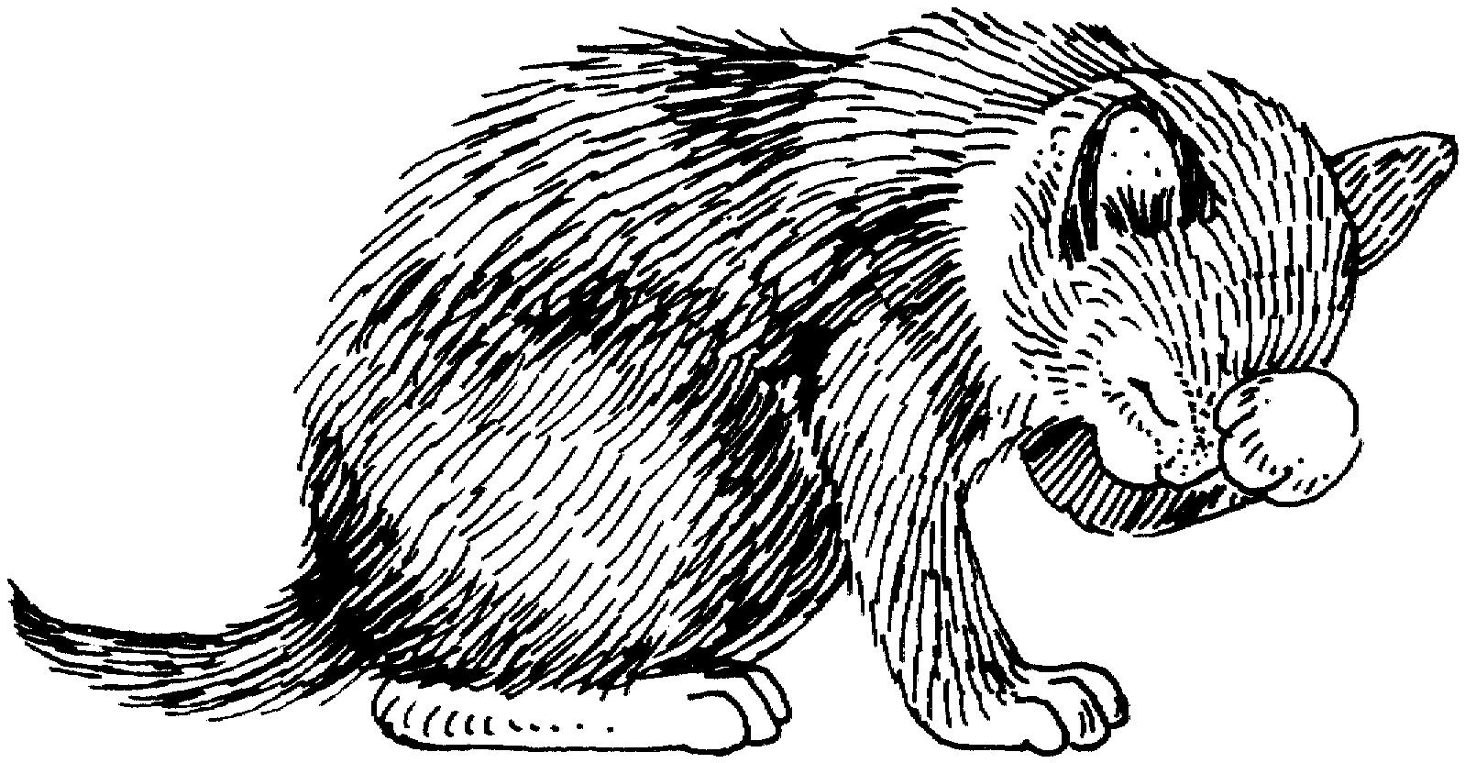

Katze | Bett | Kiste | Kopf | Hund

Dame | See | Lid | Mond | Fuß

Blockiere-einen-Laut Kästchen

________________________ ________________________ ________________________
Block-a-Sound Boxes: Adapted by permission of The Diagnostic Learning Centre, The Winnipeg School Division No. 1.

