VISION SCREENING IN MANITOBA SCHOOLS

DIRECTIONS FOR
Kindergarten, Grades 1, 3, 5, 7, 9, 11



Manitoba Education and Training  Inclusion Support Branch |  | Room 204
 |  | 1181 Portage Avenue
 |  | Winnipeg, Manitoba R3G 0T3
 |  | Phone: 204-945-7912
 |  | Fax: 204-948-3229
Refurbishing, Forms & Parts
Phone: 204-945-7912
 |  | Revised 2019

IMPORTANT TO READ AND FOLLOW THESE SUGGESTIONS:

- Parents should be notified in advance that the screening is scheduled. Vision Screening is not compulsory for any student.

- This is a Vision Screening not an eye test or vision test. It is designed to assist in the detection of possible unidentified vision difficulties. Eye tests are only done by optometrists or ophthalmologists. Because it is a screening only, it is designed not to miss any students therefore you can expect a 15% - 20% rate of over-referral.

Note: There is no cost for children under 19 years for an eye examination by an optometrist in Manitoba.

- This is not a pass/fail situation as in other types of tests. Students are given positive feedback for cooperation and are not informed as to whether they have been "passed" or "referred".

- Screening is not designed for students who wear glasses. If however a decision is made to test such a student, the test should be done with the student wearing his/her glasses.

- In addition to testing the grades outlined in the Directions many schools also screen students who are new to the school and also students whose parents or teacher request it.

- Vision is not static and can change quite dramatically without the individual necessarily being aware of it. Older students can be particularly at risk because of hormonal changes and "growth spurts", therefore, it is important that older students receive regular eye examinations.

- All equipment (particularly lenses) should be cleaned immaculately and constantly. Equipment should be thoroughly tested and assembled before student screening commences.

- Testing environment should be free of glare from windows, overhead lights, and shiny reflective surfaces.

- Testing environment should be quiet and free from distractions. The equipment should be set up so that children waiting their turn cannot observe the tests and memorize the charts.

- Assess the suitability of the screening environment by sitting and viewing the test items at precisely the same distance and viewing height as outlined in this guide.

- Always confirm that the student you are screening is the same student that you have listed on the sheet!
IMPORTANT TO READ AND FOLLOW THESE SUGGESTIONS ─ continued

- If your team is new to vision screening:
- Practice the tests on each other – it is important to personally experience what you will be asking the student to do.
- Practice with a group of students and screen them (e.g., Grade 2). There is no need to record their results but it will help the screeners to remedy any short comings in their techniques and procedures.

- Begin your testing with the older grades if possible. The younger students are the most challenging to work with.

- A student that cannot readily demonstrate mastery of the teaching component level should not proceed to be tested (Testing Component) in that particular item. He/she should be referred for a second screening. If that is unsuccessful the student is neither recorded as a pass or a refer. Suggest a call to parents to explain the situation.

- In preparation for the tests, K and 1 students should be pre-taught in their classroom to:
- point their arms the same way as the "E" points
- say "hit" when a large pointer held parallel to an arrow drawn on the blackboard touches or crosses it. Students should be taught to say "hit" precisely when the pointer is over the arrow.

Note: This pre-teaching is worthwhile for the younger children to understand the screening procedure and expectations.

- Do your best to ensure that students take their time and really take a look. Some feel it must be done quickly.

- All students in the designated grades receive the first screening. Only those students who cannot meet the test criteria from the first screening are referred for the second screening. Then they are only rescreened on the particular test that they “failed” the first time. They do not redo all the tests a second time.

- Other items to have readily at hand, in addition to the screening equipment, include:

- masking tape
- a sturdy tape

- measure
- lens cleaners

- 3 prong extension cords
- marking pens.

- Viewing distances are always measured from the student's eye ball to the surface of the object being viewed (e.g., Eye chart or Random Dot E Cards.)

THE RANDOM DOT E TEST ─ For Kindergarten and Grade 1 Only

  - Not used for any other grades
  - Tests for depth perception
  - Testing distance is 50 cm. (twenty inches) for the teaching component and one metre (39 inches) for the testing component

Teaching Component

- Have the student put on the M A G I C G L A S S E S (small black plastic glasses with 3D lenses).

- Show the student the "Model E" Card at very close visual range and have the student trace the "E" with his/her finger.

- At 50 centimeters (20 inches) distance from the student's eyes, present together several times the "Model E" Card along with the "Stereo Blank" Card. It is important to hold both cards in exactly the same manner and at the student's eye level, approximately 10 - 15 cm. (4" - 6") apart – no further. The student: "Show me which card has the E." (Student points to the "Model E" Card). Student must be able to demonstrate that they can correctly choose the "E" card consistently over several attempts.

- Put the "Model E" Card away. Present the "Raised E" Card at very close visual range. When the student finds it (sometimes it seems to be "hiding") have the student trace the "Raised E" with his/her finger. (Remember to use the card with the words "Raised E" printed at the top of the card on the reverse side. The words "Recessed E" should be at the bottom of the card and appear upside down).

Testing Component

- Move the cards ("Stereo Blank" and "Raised E") further away from the students eyes to a distance of one metre (39 inches). Present the "Raised E" Card and the "Stereo Blank" Card simultaneously using exactly the same method as in the Teaching Component above. Ask the student to: "Show me which card has the E." (Student points to the Raised E Card for a correct response).

- Present the cards a total of 4 times in succession and in random order.

PASS OR REFER CRITERIA

Pass | - identifies the "Raised E" Card 4 out of 4 times (no errors)
Refer | - unable to identify the "Raised E" Card 4 out of 4 times (one or more errors is a "refer")

THE INSTA-LINE TESTS

Note: As of January 2013 there are three generations of the Instaline. All are current, but there are differences in the control panel/remote and the electronics. Read specific instructions below.

1st Generation Instaline (brown veneer box)

  - This Instaline must be plugged in to use.
  - The “Vision ON” switch at the top of the control panel/remote must be activated before any of the other switches will work.
  - The control panel/remote is connected to the Instaline by a cord. To use, the tester must depress the switches to the left, right, up or down.
  - While conducting the Instaline tests, the student faces the eye chart and the tester faces the student (not the eye chart). The control panel is “in sync” with the eye chart.

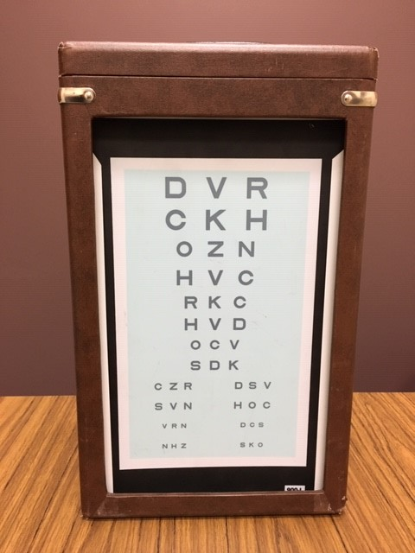
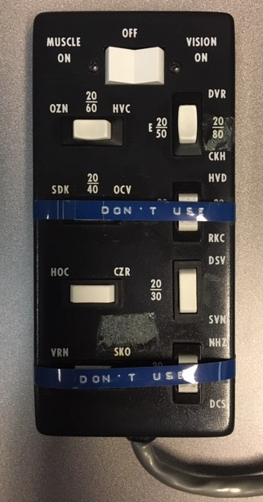
The “Vision On” switch must be activated before using.

Use the top two switches for the “teaching” component.

Use the third row of switches for the “testing” component.

NOTE: You do not use the second or last row of switches.

THE INSTA-LINE TESTS - continued

2nd Generation Instaline (Insta-line plus, beige metal container)

  - This Instaline must be plugged in to use.
  - The control panel/remote is button activated and is not connected to the Instaline by a cord. It comes with two covers (E chart and alphabet chart).
  - While conducting the Instaline tests, the tester should sit/stand off to the side, in between the student and the Instaline. The tester should have a clear view of both the student and the Instaline.

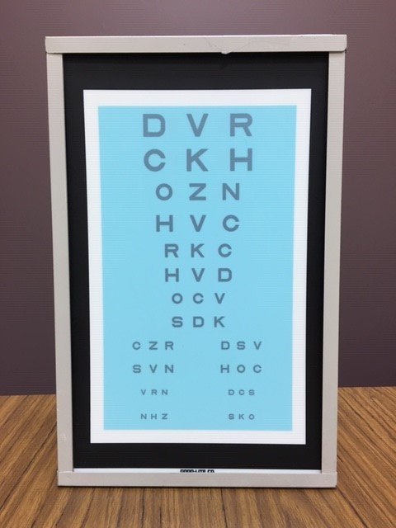
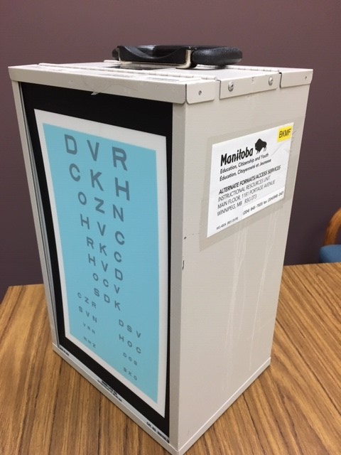

7.25”

E Chart
Alphabet Chart
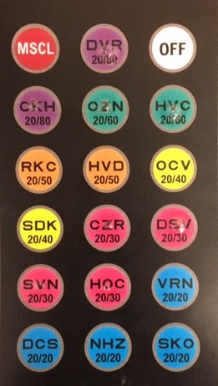
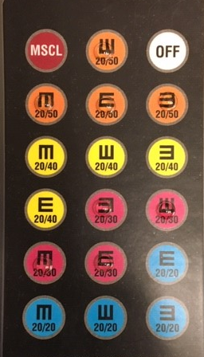
Use the two largest letters (20/80, purple and 20/60, green buttons) for the “teaching” component.
Use the largest “E”’s (20/50, orange buttons) for the “teaching” component.

Use the second smallest “E”’s (20/30, pink buttons) for the “testing” component.
Use the second smallest letters (20/30, pink buttons) for the “testing” component.

THE INSTA-LINE TESTS - continued

3rd Generation Instaline (LED Insta-Line Quantum, thin beige metal container)
- This Instaline requires charging for 24 hours or overnight. There is also an option to plug it in if needed.
- The control panel/remote is button activated and is not connected to the Instaline by a cord. It comes with two covers (E chart and alphabet chart).
- While conducting the Instaline tests, the tester should sit/stand off to the side, in between the student and the Instaline. The tester should have a clear view of both the student and the Instaline.

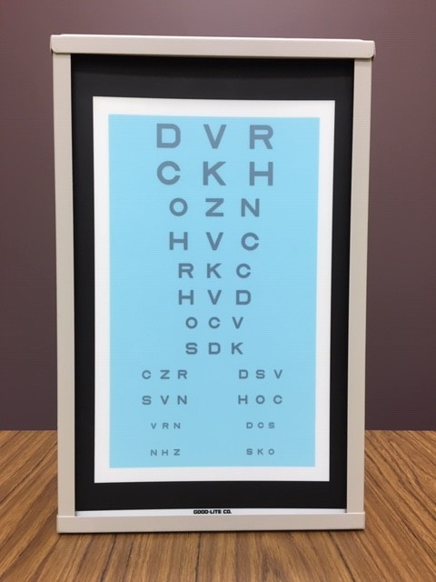
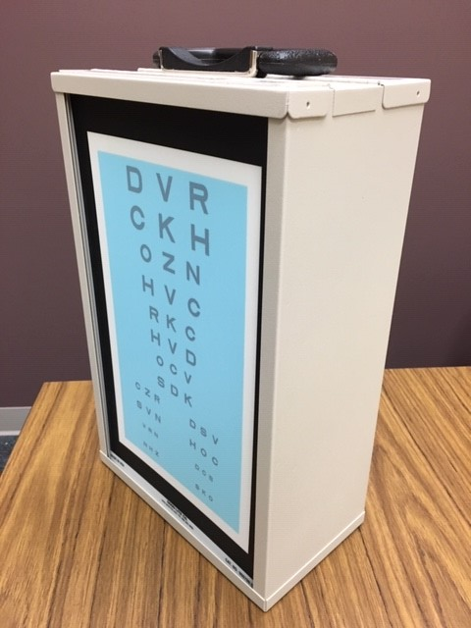

5”

E Chart
Alphabet Chart
Use the largest “E”’s (20/50, orange buttons) for the “teaching” component.
Use the two largest letters (20/80, purple and 20/60, green buttons) for the “teaching” component.

Use the second smallest letters (20/30, pink buttons) for the “testing” component.
Use the second smallest “E”’s (20/30, pink buttons) for the “testing” component.

THE INSTA-LINE TESTS ─ Kindergarten and Grade 1

- use only the "E" chart, not the alphabet letters for these grades
- two different tests are done with this instrument
- testing distance from chart to eye = 10 feet (3 metres)
- requires teaching component

Teaching Component ─ covers both tests #1 and #2 that follow

- The student faces the eye chart.

- If using a generation #1 Instaline (brown veneer box), the tester sits facing the student, not the eye chart. Determine correctness of student responses according to the buttons depressed on the control panel/remote.

- If using a generation #2 or #3 Instaline (beige metal container), the tester sits/stands off to the side in between the student and the Instaline, with a clear view of both the student and the Instaline. Determine correctness of student response according to the eye chart.

- Introduce the student to the chart by using the top row of switches/buttons on the control panel/remote highlighting the largest letters on the eye chart. Direct the student to: "Show me which way the E points."

- Do this several times, with the "E" facing different directions, until you are satisfied the student clearly can demonstrate their ability to point his/her arms in the same direction that you called for on the control panel/remote.

TEST #1 MYOPIA

  - tests the ability to see at a distance
  - sometimes referred to as "short sighted"
  - only one eye at a time is permitted to view the chart

Testing Component

- Have the student cover one eye with an occluder (eye patch) and highlight the four different positions of the letter "E" using the second smallest letters on the eye chart. At each different position the student should be asked to point in the same direction as the "E" points.

- After a brief rest period to allow the covered eye to clear itself, cover the other eye with an occluder and present the four positions of the letter "E" in a different sequence, using the second smallest letters on the eye chart. Ask the student in each case to show you which way the "E" is pointing.

THE INSTA-LINE TESTS ─ Kindergarten and Grade 1 continued

PASS OR REFER CRITERIA

Pass – can identify 3 out of 4 positions with one eye (note: both eyes must be screened).

Refer – 2 or more errors in one eye

TEST #2 HYPEROPIA

  - tests the ability to focus both eyes together at near distance
  - +2.25 lenses (the children's glasses)

Testing Component

- Have the student put on the +2.25 lenses (glasses).

- Highlight the second smallest line on the control panel/remote. Ask the student to show you which way the "E" points in each of the four different positions.

- If the student has been unable to see with the glasses on, have the student remove the glasses; then quickly show them the largest "E's" on the eye chart several times (largest line on the control panel/remote) to reduce student anxiety. Provide reassurance to the student that he/she has done a great job. Never explain to the student that "he/she was not supposed to be able to see with these thick glasses on."

Note: In this test the student is referred if they are able to see with the special glasses on. This is a reversal of the way in which the results are interpreted for all of the other tests.

PASS OR REFER CRITERIA

Pass – cannot identify 3 out of 4 positions of the “E” with the +2.25 glasses on

Refer – can identify at least 2 out of 4 positions of the “E” with the +2.25 glasses on

THE INSTA-LINE TESTS ─ Grade 3 and Up

  - use the alphabet chart for most students (the "E" chart should only be used with students who are EAL or developmentally delayed)
  - two different tests are done with this instrument
  - testing distance from eye to chart = 10 feet (3 metres)
  - no teaching component necessary for most students

Test #1 Hyperopia

  - test to check the ability to focus both eyes together at near distance +2.25 lenses (hand-held glasses)
  - conducted before the myopia test to reduce the opportunities for the student to memorize the chart

Testing Component

- The student faces the eye chart. The tester sits facing the student not the eye chart. Have the student hold the +2.25 hand-held glasses to his/her eyes and face the eye chart.

- Highlight the second smallest letters on the control panel/remote using four different positions using random order selection. Ask the student to read the letters at each highlighted position. Identifying any of the letters is considered a mistake.

- Have the student remove the hand-held glasses. Highlight the largest letters on the control panel/remote. Ask the student to read the chart. This technique reduces anxiety for students who have been unable to read the letters with the glasses on. They should never be told that "they were not supposed to be able to see with those glasses on.”

Note: In this test the student is referred if they are able to see with the special glasses on. This is a reversal of the way in which the results are interpreted for the other tests.

PASS OR REFER CRITERIA

Pass – cannot identify letters in 3 out of 4 trials with +2.25 glasses on

Refer – can identify letters at least 2 out of 4 trials with +2.25 glasses on

Test #2 Myopia

  - a test to check the ability to see at a distance
  - sometimes referred to as "short-sighted"
  - only one eye at a time is permitted to view the chart

THE INSTA-LINE TESTS ─ Grade 3 and Up continued

Testing Component

- Have the student cover one eye with the occluder (eye patch). Highlight the second smallest letters on the control panel/remote. Test all four positions/buttons.

- After a brief rest period to allow the covered eye to clear itself, cover the other eye with an occluder and highlight the second smallest letters on the eye chart. Test all four positions/buttons in a different sequence.

PASS OR REFER CRITERIA

Pass – can identify 3 out of 4 trials with one eye (note: both eyes must be screened, a total of one error per eye is permitted)

Refer – more than one error per eye

THE BIOPTER TESTS ─ Using the 3 Circle Target Cards

  - All grades
  - Tests the ability of the 2 eyes together to focus simultaneously
  - Three different tests are done with this instrument

Note: There are 3 generations of the biopter. All are still current.
- The first generation is metal with a black screw-in handle for adjustment. There is no longer a need to plug in the unit.
- The second generation is plastic and uses a spring clip.
- The third generation is also plastic but has a screw to adjust height.

Preparation

- There is no longer any requirement to turn on the biopter lights. In fact they can cause dangerous over heating of the metal shields. The new models of the biopter do not come equipped with lights. A good, glare free source of regular lighting is sufficient.

- The black plastic card holder is placed on the shaft by squeezing together the spring clip (or by using the screw to adjust the card holder. The card holder will be moved to near and far marked positions as indicated by the test.
THE BIOPTER TESTS ─ Using the 3 Circle Target Cards ─ continued

Preparation ─ continued

- The Circle Target Card Booklet is then inserted into the slot on the card holder. (or between the ridges on the newer models). It is very important that every page in the booklet – including the one that is currently being viewed – is inserted into the slot on the card holder each time a page is turned. This will prevent the page, being viewed, from protruding forward and thus not be straight or at a precise distance from the student's eyes.

- Have the student stabilize his/her position at the biopter by placing both hands over the base of the instrument with the forearms and elbows on the table. Many testers choose to secure the biopter base to the table with masking tape.

- Have the student lean forward and look through the biopter lenses without pressing his/her eyes against the lens piece or without being too far back.

- The forehead should contact the "rest" comfortably.

- It is the responsibility of the tester to raise or lower the angle (height) of the metal biopter (to suit the student and to ensure that the student's eyes are at a correct distance from the lens at all times. The plastic biopter can be adjusted by pulling (stretching apart). The metal biopter uses the black handle and screw to adjust.

- Student should be instructed to focus on the arrow on the card and not attempt to visually follow the moving pointer stick.

- Should the masking tape/plastic tabsat either end of the shaft become damaged or inadvertently removed it must be replaced in precisely the following manner:

  - at the bottom end of the shaft place a ½ inch section of masking tape wound around the shaft several times, between the letter "B" and the letter "C". For the correct position the card itself will then rest on the card holder exactly on the "O" mark.
  - at the top end of the shaft place a ½ inch section of masking tape, wound around the shaft several times, centered over the number 12. For the correct position the card itself will then rest on the card holder exactly on the "10" mark.
THE BIOPTER TESTS ─ (All Grades) ─ continued

Vertical Phoria At Far (Card #3 - is displayed on the cardholder)

Teaching Component (Work on the left/arrow side of the card)

- The card holder is DOWN the shaft as far as possible to the marked position (the card itself will then be at the zero mark on the shaft). This means that the card is at a maximum distance away (at far) from the viewing lens.

- Introduce the pointer and ask the child to:
"Say 'hit' when the pointer touches or crosses the arrow". It is important to keep the pointer parallel to the arrow.

- With your pointer in a horizontal position parallel to the arrow, move the pointer slowly and smoothly down the card past the arrow without stopping on it. Repeat, moving the pointer up and down the card until the student consistently says 'hit' when the pointer touches or crosses the arrow. It is a good idea to suggest that the student concentrate on looking at the arrow instead of trying to visually follow the moving pointer stick.

Testing Component (Work on right /circle side of the card)

- In the same manner as used in the teaching component move the pointer slowly and smoothly from above the circle to below the circle and back again, asking the student to say 'hit' when the pointer touches or crosses the arrow. Always keep your pointer parallel to the arrow.

- Repeat from below the circle and again from the top of the circle several times.

PASS OR REFER CRITERIA

Pass | ─ | Student says 'hit' either on the circumference or anywhere inside the circle in a consistent manner. (May make the occasional incorrect response but in most cases is correct.)
Refer | ─ | Student says 'hit' outside the circumference of the circle and is incorrect in his/her responses most of the time.

THE BIOPTER TESTS ─ (All Grades) ─ continued

Lateral Phoria At Far (Card #4 is displayed on the card holder)

Teaching Component (Work on the left/arrow side of the card)

- The card holder is DOWN the shaft as far as possible to the marked position.

- With your pointer in a vertical position parallel to the arrow, move the pointer slowly and smoothly across the card past the arrow without stopping on it. Repeat, moving the pointer from side to side across the card until the student consistently says 'hit' when the pointer touches or crosses the arrow. It is a good idea to suggest that the student concentrate on looking at the arrow instead of trying to visually follow the moving pointer stick.

Testing Component (Work on the right/circle side of the card)

- Move the pointer slowly from the left side of the circle to beyond the right side of the circle and back again. Ask the student to say 'hit' when the pointer touches or crosses the arrow. Always keep your pointer parallel to the arrow.

- Repeat several times.

PASS OR REFER

Pass | ─ | Student says 'hit' either on the circumference or anywhere inside the circle in a consistent manner. (May make the occasional incorrect response but in most cases is correct).
Refer | ─ | Student says 'hit' outside the circumference of the circle and is incorrect in his/her responses most of the time.

THE BIOPTER TESTS ─ (All Grades) ─ continued

Lateral Phoria At Near (Card #5)

Teaching (Work on the left/arrow side of the card)

- **Move the card holder into the NEAR position (the card is at the ten mark on the shaft or as high as it can go to the upper marked position). It is crucial that the card be moved up the shaft from its previous "far" position at the bottom of the shaft.

- With your pointer in a vertical position parallel to the arrow, move the pointer slowly and smoothly across the card past the arrow without stopping on it. Repeat, moving the pointer from side to side across the card until the student consistently says 'hit' when the pointer touches or crosses the arrow. It is a good idea to suggest that the student concentrate on looking at the arrow instead of trying to visually follow the moving pointer stick.

Testing Component (Work on right/circle side of the card)

- Move the pointer slowly from before the left side to beyond the right side of the circle and back again. Ask the student to say "hit" when the pointer touches or crosses the arrow. Always keep your pointer parallel to the arrow.

- Repeat several times.

- Return the card holder at this time to the "down" or "at Far" position to ensure that it will be in the proper position for the next student.

PASS OR REFER

Pass | ─ | Student says 'hit' either on the circumference of anywhere inside the circle in a consistent manner. (May make the occasional incorrect response but in most cases is correct).
Refer | ─ | Student says 'hit' outside the circumference of the circle and is incorrect in his/her responses most of the time.

PROCEDURES FOR SECOND SCREENING ─ ALL GRADES

- Second screening should definitely not be done the same day. Try to conduct the second screening after an interval of two or three days.

- Conduct the second screening for only those students who had referrals (failures) on the first screening.

- Conduct a second screening on only the particular test (s) in which the student was referred.

- Repeat the same test as you did for the first screening. Use the same pass/refer criteria.

- A special exception is made for the Hyperopia (+2.25 lenses) – Insta-line test if both the first and the second screenings are "referrals". In the event of such an occurrence you should add the following steps:

- With the student still wearing the +2.25 lenses hold the white (5"x5") cardboard with the black "E" in the center, directly in front of the Insta-line Screen. This will ensure that the students eyes are at an exact distance of 10 feet (3 metres) from the card.

- Show the "E" on this card in four different positions and ask the student to: "Show me which way the E points". (Do not allow the student to observe how you change the positions of the E-card),

- PASS/REFER criteria is the same as it was for the first screening.
PACKING EQUIPMENT

When repacking equipment please follow the directions below. This will ensure the equipment can be used efficiently at future vision screenings. Newer versions of the Biopter are called "Bernelloscopes".

- Repack equipment in the container appropriate to the test.
e.g., Biopter cards etc. in the biopter bag and the occluder (patch) etc., in the Instal-line Box.

- The Random Dot E Cards and the Magic Glasses should be placed in a Ziploc Bag and packed in the biopter case.

- The lens mount on the metal biopter need not (should not) be undone for packing – simply unscrew the black handle on the underside of the biopter track and remove the cards and card holder from the top side of the track. The unit will then fit in the biopter bag with no difficulty. Plastic biopters adjust/fold down easily to fit the bag.

- Spare bulbs are supplied for emergency use. Discard any defective bulbs.

Note: With the third generation Instaline no bulbs are used.

Insta-line box Includes: |  | Biopter (Bernelloscope) Case Includes:
1. | 2 eye charts (one "E" and one with Alphabet letters). | 1. | 1 Random Dot E kit (RDE cards and magic glasses) in a Ziploc bag.  (Random Dot E Cards - to include:  1 Stereo Blank, 1 Model E and 1 Raised E).
2. | Control-panel/remote and cords attached. | 2. | Several wooden pointer sticks.
3. | Hand held glasses (+2.25 lenses). | 3. | Biopter viewing lenses still mounted on the biopter shaft.
4. | Children's glasses (+2.25 lenses). | 4. | Black plastic card holder.
5. | Occluder (eye patch). | 5. | Black handle (older metal unit).
6. | Bulb changer with spare bulbs  (discard defective bulbs).
7. | Small white card (approx. 5"x5")  with one black "E" in the center.
8. | Large handmade cardboard, construction paper or wooden "E's"  may sometimes be included and are used in grades K and 1 for the pre-teaching.

Page 1
VISION SCREENING RESULTS FOR SCHOOL YEAR ____________ DATE _____________

SCHOOL DIVISION NAME AND NUMBER ___________________________________________
SCHOOL NAME ________________________________________________________________
CLASSROOM TEACHER _________________________ ROOM # ______ GRADE: ______

RANDOM DOT E TEST (Kindergarten and Grade 1 only)

 = Pass R = Refer

STUDENT  NAME | FIRST  SCREENING | SECOND  SCREENING | REFERRED FOR  PROFESSIONAL  EXAMINATION
STUDENT TOTAL

(…over)
Page 2
RANDON DOT E TEST (Kindergarten and Grade 1 only) ─ continued

 = Pass R = Refer

STUDENT  NAMES | FIRST  SCREENING | SECOND  SCREENING | REFERRED FOR  PROFESSIONAL  EXAMINATION
STUDENT TOTAL
GRAND TOTAL OF STUDENTS
(Page 1 and 2)

Page 1
VISION SCREENING RESULTS FOR SCHOOL YEAR ____________ DATE _____________

SCHOOL DIVISION NAME AND NUMBER ___________________________________________
SCHOOL NAME ________________________________________________________________
CLASSROOM TEACHER _________________________ ROOM # ______ GRADE: ______

BIOPTER TESTS (All Grades)

 = Pass R = Refer

STUDENT NAMES | VERTICAL PHORIA  AT FAR |  |  | LATERAL PHORIA  AT FAR |  |  | LATERAL PHORIA  AT NEAR
STUDENT NAMES | FIRST  SCREENING | SECOND  SCREENING | REFERRED  FOR PROF.  EXAM. | FIRST  SCREENING | SECOND  SCREENING | REFERRED  FOR PROF.  EXAM. | FIRST  SCREENING | SECOND  SCREENING | REFERRED  FOR PROF.  EXAM.
STUDENT TOTAL
(…over)
BIOPTER TESTS (All Grades) ─ continued page 2

 = Pass R = Refer

STUDENT NAMES | VERTICAL PHORIA  AT FAR |  |  | LATERAL PHORIA  AT FAR |  |  | LATERAL PHORIA  AT NEAR
STUDENT NAMES | FIRST  SCREENING | SECOND  SCREENING | REFERRED  FOR PROF.  EXAM. | FIRST  SCREENING | SECOND  SCREENING | REFERRED  FOR PROF.  EXAM. | FIRST  SCREENING | SECOND  SCREENING | REFERRED  FOR PROF.  EXAM.
STUDENT TOTAL
GRAND TOTAL OF STUDENTS
(Page 1 and 2)

Page 1
VISION SCREENING RESULTS FOR SCHOOL YEAR ____________ DATE _____________

SCHOOL DIVISION NAME AND NUMBER ___________________________________________
SCHOOL NAME ________________________________________________________________
CLASSROOM TEACHER _________________________ ROOM # ______ GRADE: ______

INSTA-LINE TESTS (All Grades)

 = Pass R = Refer

STUDENT NAMES | MYOPIA TEST |  |  | HYPEROPIA TEST
STUDENT NAMES | FIRST  SCREENING | SECOND  SCREENING | REFERRED  FOR PROF.  EXAM. | FIRST  SCREENING | SECOND  SCREENING | REFERRED  FOR PROF.  EXAM.
STUDENT TOTAL

(…Over)
INSTA-LINE TESTS (All Grades) page 2

 = Pass R = Refer

STUDENT NAMES | MYOPIA TEST |  |  | HYPEROPIA TEST
STUDENT NAMES | FIRST  SCREENING | SECOND  SCREENING | REFERRED  FOR PROF.  EXAM. | FIRST  SCREENING | SECOND  SCREENING | REFERRED  FOR PROF.  EXAM.
STUDENT TOTAL
GRAND TOTAL OF STUDENTS
(Page 1 and 2)

SCHOOL LETTERHEAD

Date: ____________________________

Dear Parents:

A Vision Screening will be carried out at your child's school in the near future.

This screening program is designed to uncover signs of any possible vision difficulty which may interfere with school progress. It is not intended to be a substitute for the vision examination performed by an Ophthalmologist/Optometrist. If you do not wish that your child participate in this no-cost vision screening please contact the school.

Children who are currently wearing glasses will not usually be screened. Parents of children who wear glasses will be receiving a form to take or send to their Ophthalmologist or Optometrist to assist the school in the best programming for their child.

If after the vision screening has been completed you receive a notice from the school requesting that you refer your child for a professional eye examination, please follow-up by making an appointment with an eye doctor (Ophthalmologist/Optometrist) of your choice. Ask the eye doctor to complete the form sent to you by the school and then return this completed form to the school.

If you require any further information please contact the school.

__________________________
Principal

SAMPLE LETTER TO PARENTS INFORMING THEM OF SCHOOL PLANS TO CONDUCT A VISION SCREENING

SCHOOL LETTERHEAD

Dear Parent:

Student Name: ____________________________________________________________________________
(Full Name Printed Clearly)

Date: _______________________________________ Grade: ____________________________

While conducting our Vision Screening we noted that your child is wearing glasses. Children wearing glasses are not usually tested since it is assumed that they are already receiving professional eye care from either an ophthalmologist or an optometrist.

We would like the Ophthalmologist/Optometrist who prescribed glasses for your child to complete the attached form. If the visit to the eye doctor has been recent, you may send the form directly to the Ophthalmologist/Optometrist's office for completion. If it has been over 1 year since your child has been seen by an Ophthalmologist/Optometrist, an appointment is in order. Whichever, course of action is appropriate please ask the Ophthalmologist/Optometrist to complete the following form and send it to your child's school.

Dear Ophthalmologist/Optometrist:

When doing the Vision Screening in this students' school it was noted that this child was wearing glasses. We request your cooperation in answering the questions with respect to this child who is one of your patients.

For Completion by the Ophthalmologist/Optometrist

Please Circle Your Responses

1. | Should this student wear glasses all the time in school?  If sometimes, when? | YES | NO
 | _______________________________________________________
2. | Should this student have some special seating arrangement?  If yes, please specify. | YES | NO
 | ____________________________________________________________
3. | Should the Resource Teacher from the school contact you? | YES | NO
 | ____________________________________________________________
4. | Comments (use the reverse side if more space is required).

** | Please complete and return this form to the student's  school as listed at the top of the page. | ______________________________
 |  | Ophthalmologist/Optometrist Signature

Please print doctors name or use office stamp here.

SAMPLE LETTER TO PARENTS OF STUDENTS WHO WEAR GLASSES

SCHOOL LETTERHEAD

Date: _______________________________

Dear Parent:

A Vision Screening has been conducted recently at our school. On the basis of the results of this screening, we would suggest that you make arrangements to have your child

______________________________________________ examined by a professional eye
(Student's Full Name)

care practitioner (Ophthalmologist/Optometrist).

If your child has been seen by an Ophthalmologist/Optometrist within the past year please send him/her the enclosed form(s) for completion. If your child has not had a professional eye examination in the recent past please make an appointment with an ophthalmologist or optometrist of your choice. At that appointment ask the eye doctor to complete the attached form and return it to the school.

It is very important that the eye doctor's report is returned to the school in order that the most effective educational programming can be offered to your child.

Thank you for your cooperation.

Yours truly,

___________________________________
Resource Teacher

SAMPLE LETTER TO PARENTS OF STUDENTS WHO WERE UNSUCCESSFUL ON ONE OR MORE OF THE VISION SCREENING TESTS

SCHOOL LETTERHEAD

TO BE COMPLETED BY THE SCHOOL Date ________________________

NAME OF STUDENT ____________________________________ GRADE ________
(Full Name Printed Clearly)

This student is being referred on the basis of being unable to correctly respond to the following test/tests. (Teachers should mark those tests failed with an "R").

1. | Random Dot E | ( ) | 4. | Biopter-Vertical Phoria at Far | ( )
2. | Insta-Line – Myopia (Visual Acuity) | ( ) | 5. | Biopter-Lateral Phoria at Far | ( )
3. | Insta-Line – Hyperopia (+2.25 lens) | ( ) | 6. | Biopter-Lateral Phoria at Near | ( )

-------------------------------------------------------------------------------------------------------------------------------------------------------

RECOMMENDATION FROM OPHTHALMOLOGIST/OPTOMETRIST

Eye doctor please indicate with either an "X" (disagree) or a "" (agree) beside any of the above items that are marked with an "R".

A. Are glasses recommended? ______________ If so,

PLEASE CIRCLE YOUR RESPONSES:
1. | Should this student wear glasses all the time in school? | YES | NO
 | If sometimes when? ___________________________________________________
2. | Should this student have some special seating arrangements? | YES | NO
 | If yes, please specify. __________________________________________________
3. | Should the Resource Teacher from the school contact you? | YES | NO

B. At Risk ─ Want to see in 6 months ______ Want to see in 12 months ______ No Problem ______

C. Comments ─ (may also use reverse side) _____________________________________________________

___________________________________ ____________________________________________
Date Professional Signature

** Please use Office Stamp or Print Doctor's name here.

SAMPLE FORM TO BE COMPLETED AND SENT HOME FOR ANY STUDENT WHO FAILS BOTH FIRST AND SECOND SCREENINGS ON ANY OF THE VISION SCREENING TESTS

VISION SCREENING RESULTS FOR SCHOOL YEAR __________________

SCHOOL DIVISION AND NUMBER _________________________________________________

SCHOOL NAME (For Division use only) ____________________________________________

RANDOM DOT E TEST
(Kindergarten and Grade 1 Only)

 | SCREENING |  |  | COMMENTS
GRADE | # STUDENTS  SCREENED | # STUDENTS FOR SECOND SCREENING | # REFERRED FOR PROFESSIONAL EXAMINATION
K
1
TOTAL

VISION SCREENING RESULTS FOR SCHOOL YEAR __________________

SCHOOL DIVISION AND NUMBER _________________________________________________

SCHOOL NAME (For Division use only) ____________________________________________

BIOPTER TESTS (All Grades)

 |  | VERTICAL PHORIA AT FAR |  | LATERAL PHORIA AT FAR |  | LATERAL PHORIA AT NEAR |  | COMMENTS
GRADE | # STUDENTS SCREENED | # STUDENTS FOR SECOND SCREENING | # REFERRED FOR PROF. EXAM. | # STUDENTS FOR SECOND SCREENING | # REFERRED FOR PROF. EXAM. | # STUDENTS FOR SECOND SCREENING | # REFERRED FOR PROF. EXAM.
K
1
3
5
7
S1
S3
TOTAL

VISION SCREENING RESULTS FOR SCHOOL YEAR __________________

SCHOOL DIVISION AND NUMBER _________________________________________________

SCHOOL NAME (For Division use only) ____________________________________________

INSTA-LINE TESTS (All grades)

 |  | MYOPIA TEST |  | HYPEROPIA TEST |  | COMMENTS
GRADE | # STUDENTS SCREENED | # STUDENTS FOR SECOND SCREENING | # REFERRED FOR PROF. EXAM. | # STUDENTS FOR SECOND SCREENING | # REFERRED FOR PROF. EXAM.
K
1
3
5
7
S1
S3
TOTAL

