
Pregnancy and Drugs
BLM
S1-4.2

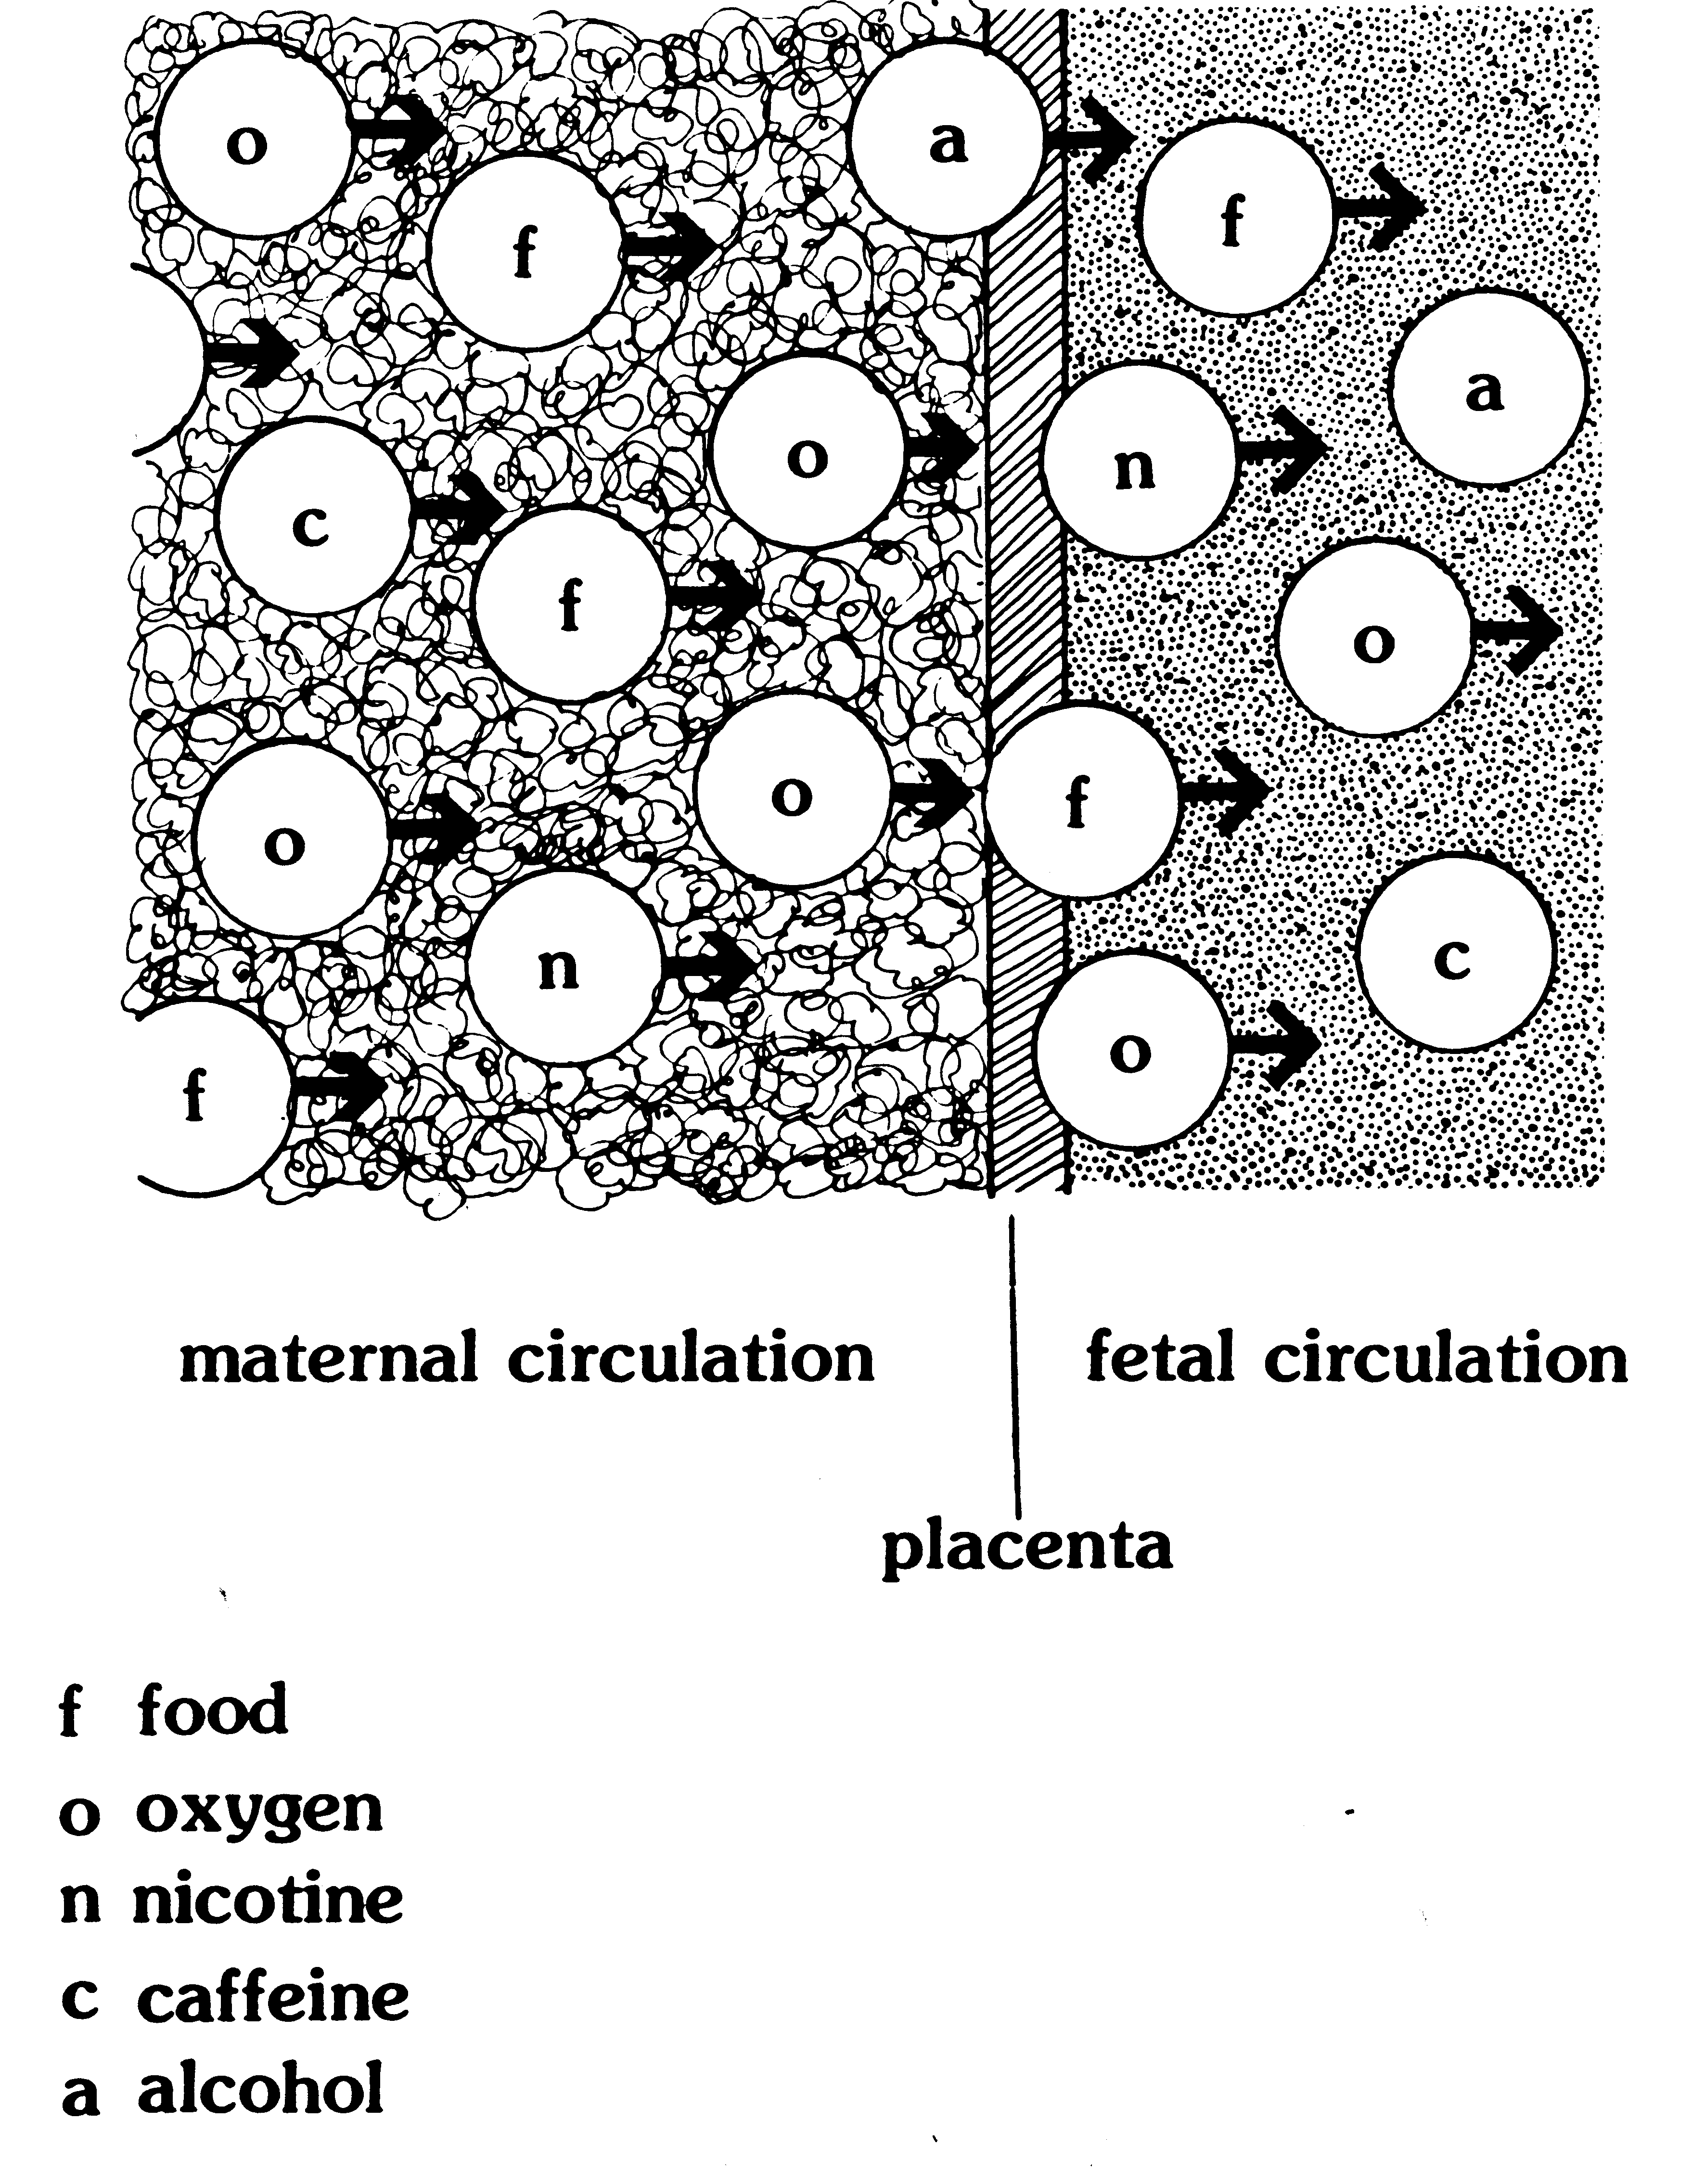

K.5.S1.E.1c

Pregnancy and Drugs: Reproduced from Family Life Education, Grade 9. Copyright © 1990 by Manitoba Education and Training.

