 | The Menstrual Cycle |  |   BLM  5-1.1
Name |  | Class | Date
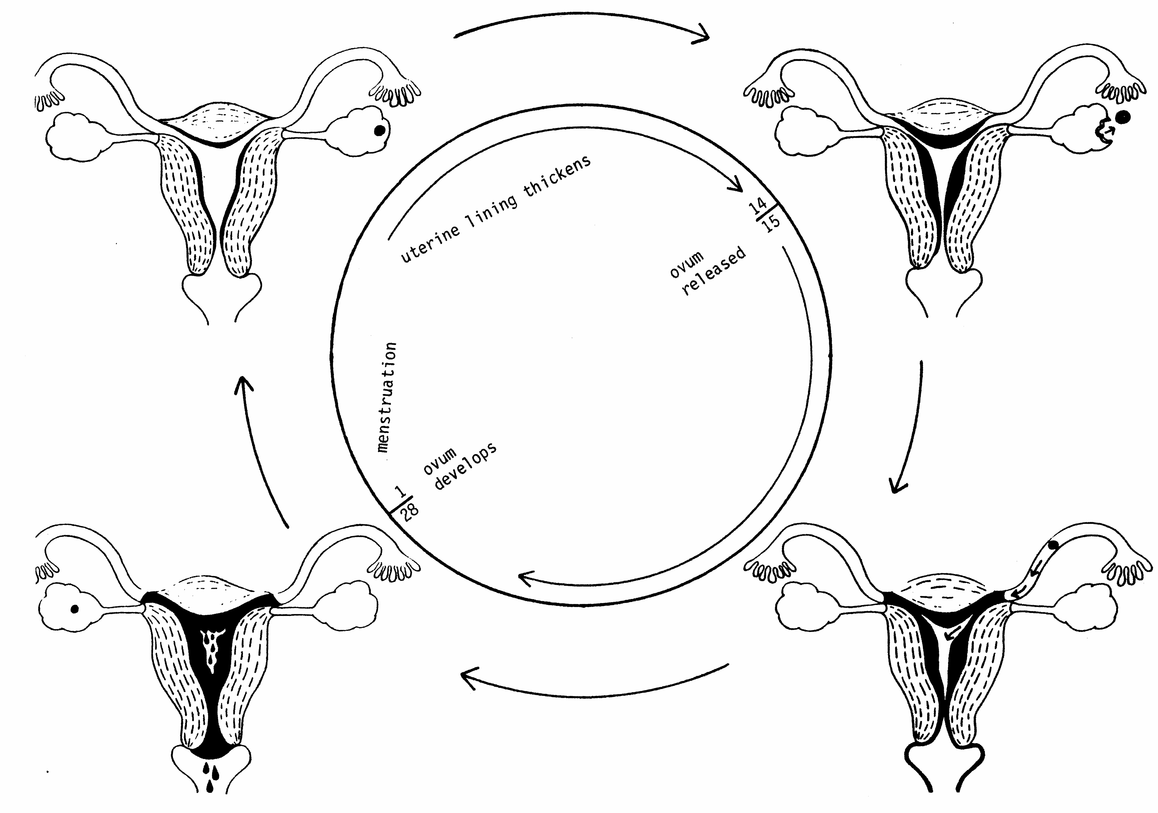
Stages of the Menstrual Cycle
Based on the diagram above, indicate on the following graph the stages of the menstrual cycle at the specified times/days (1, 12 to 16, 28).
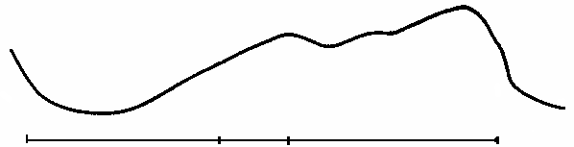
Days 1 12 16 28+

_______________________
The Menstrual Cycle: Reproduced from Family Life Education, Grade 5. Copyright © 1990 by Manitoba Education
and Training.
___________________
The Menstrual Cycle: Reproduced from Family Life Education, Grade 5. Copyright © 1990 by Manitoba Education and Training.

