BLM  G-4g  K.5.S1.E.1a  K.5.S2.E.1a | Reproductive System:  Male Anatomy—Definitions | 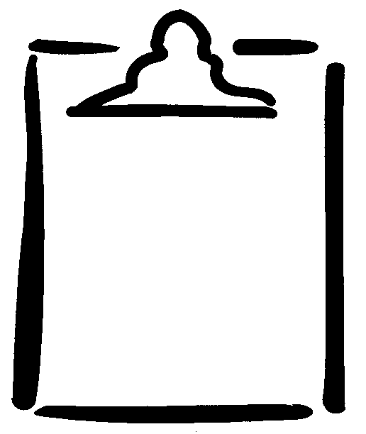

anus | the outlet of the rectum lying in the fold between the buttocks. The opening at the end of the anal canal.
circumcision  Cowper’s glands | the operation to remove the foreskin of the penis.  a pair of small glands at the base of the penis that secrete seminal fluid.
epididymis | a long, tightly coiled duct that carries sperm from seminiferous tubules of the testes to the vas deferens.
foreskin | the loose fold of skin that covers the end of the penis. Foreskin is removed during circumcision.
glans | the head of the penis.
penis | the sex organ of generation.
prostate | a walnut-sized gland that surrounds the neck of the bladder and urethra. This gland helps produce the milky semen necessary for carrying sperm.
scrotum | the wrinkly sac of skin, sparsely covered with hair, that holds the testicles.
seminal vesicles | the two sac-like glands at the base of the bladder and connected to the prostate gland that provide nutrients for the semen.
testicle/testis | the organ located behind the penis that produces sperm.
urethra  urinary bladder | a tube leading from the bladder that carries urine through the penis to the opening at the tip of the glans. Semen also passes through this tube.  the organ that holds urine excreted by the kidneys.
vas deferens | the tube that transports sperm from the epididymis from each testicle to the urethra in the prostate gland. (Also referred to as ductus deferens.)

