BLM  K-8  K.5.K.E.1a | My Body |  | 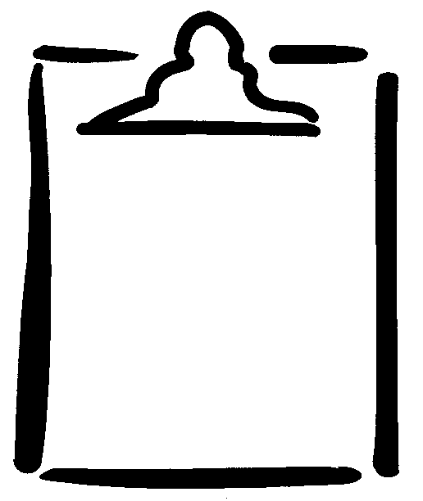
Name |  | Class | Date

