K.2.6.A.1  BLM  G-11  S.2.6.A.1a | Skill-Related Fitness  Components Poster | 


Agility “the ability to shift the body in different directions quickly and efficiently” (Kirchner and Fishburne 701).
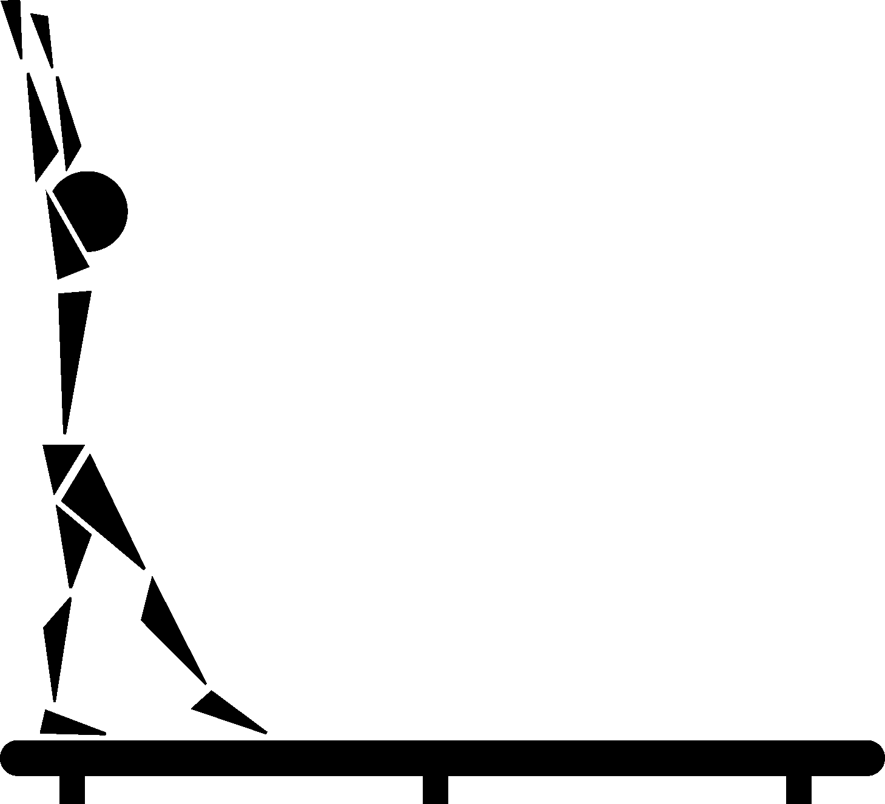
Balance “the ability to control or stabilize your equilibrium while moving (dynamic balance) or staying still (static balance).”

Coordination “the ability to use your eyes and ears to determine and direct the smooth movement of your body” (e.g., hands, feet, arms, head) (Rainey and Murray 395).

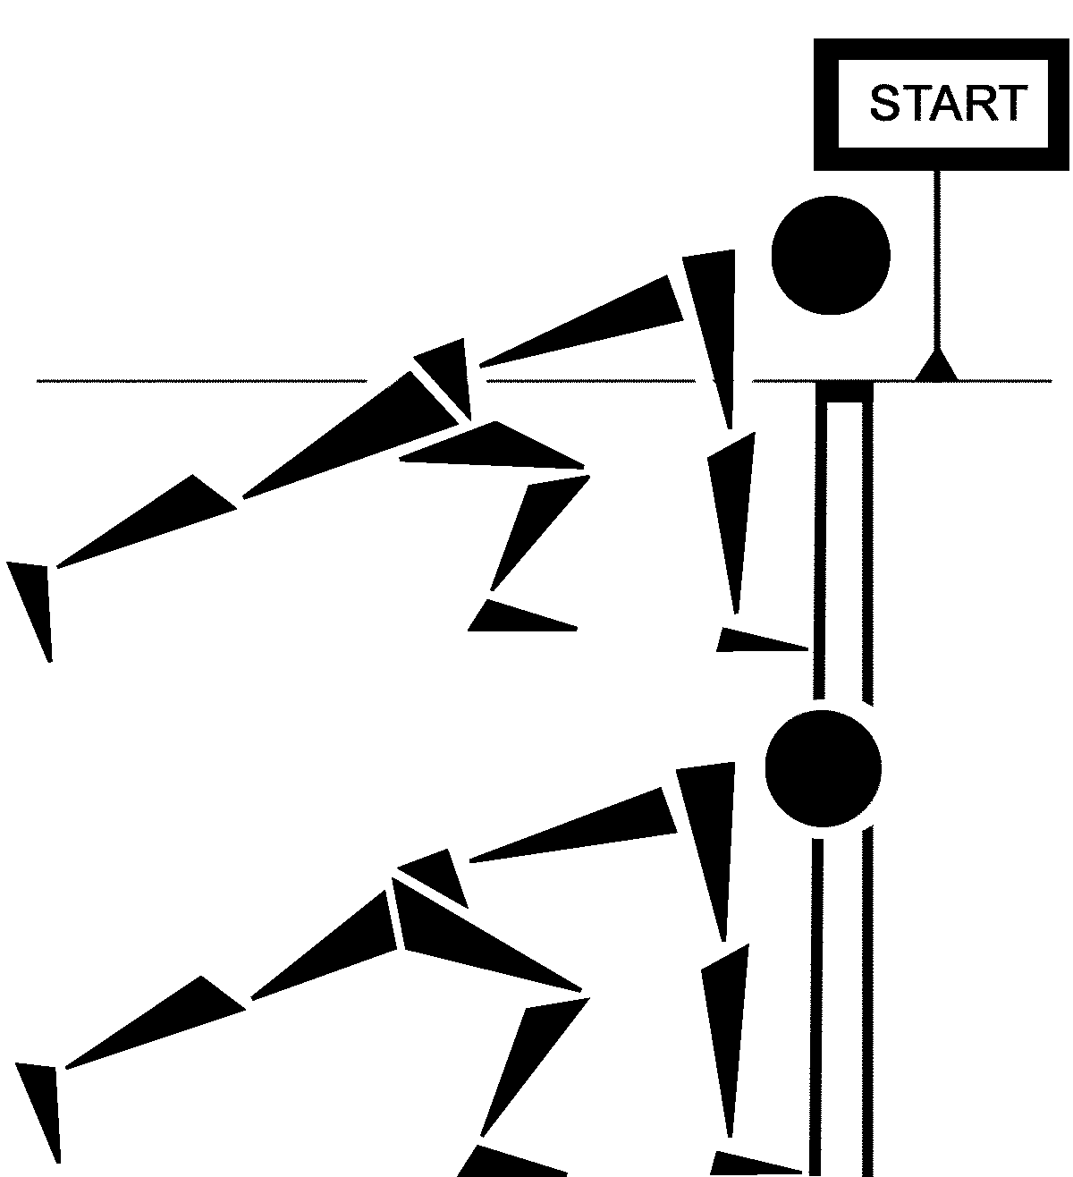
Power “the ability of the body to apply a maximum muscular contraction with the quickest possible speed” (Kirchner and Fishburne 706).

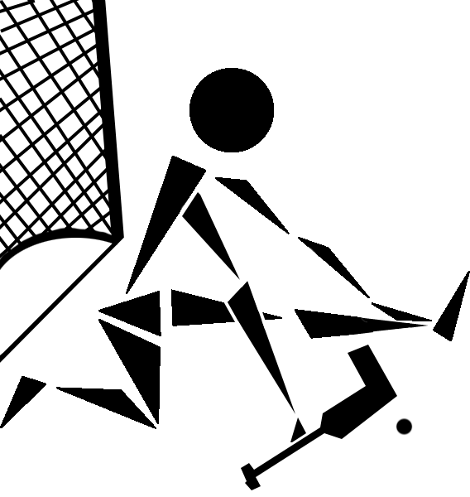
Reaction Time “the ability to react or respond quickly to what you hear, see, or feel” (Rainey and Murray 398).


Speed “the ability to move your body or parts of your body swiftly” (Rainey and Murray 399).

