Instructions:

1. Think of the person you most admire. Reflect on this person and why you chose him or her.
2. Write one quality of this admired person in each of the stones of the inukshuk on the handout (11 qualities in total).
3. Often, we are drawn to people who have some of the same qualities we have. Write the words “I am” at the top of your inukshuk, and think of yourself as possessing all of the qualities you have written down.
4. Reflect in writing below about how accurately the qualities describe you. Which qualities need to be developed more for you to become the kind of person that you admire? How might you develop these qualities?

Source: Emily Silvester in Lorraine Haché and Clarence de Schiffart. Blueprint Implementation Guide. National Life/Work Centre et al., 2002. 30–31. Appendix 1BA3 Adapted with permission of National Life/Work Centre.

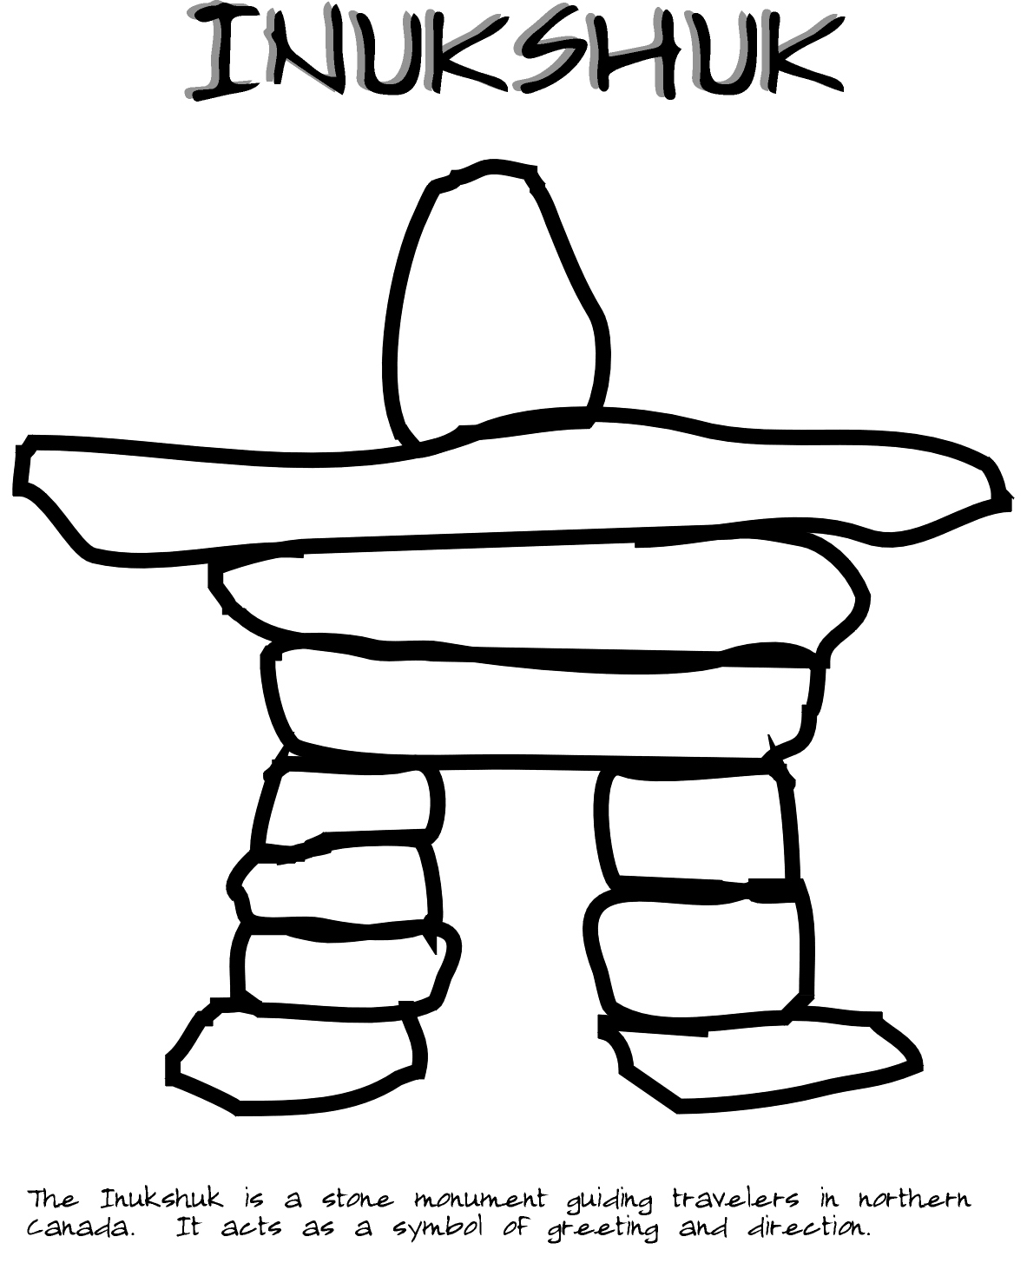
The Inukshuk is a stone monument guiding travellers in northern Canada. It acts as a symbol of greeting and direction.

